MS-6M-360

**Instruction Manual**

**MS-6M-360 infrared motion sensor**

The sensor has great detection sensitivity via integrated circuitry. It utilizes the infrared energy from humans as the control-signal source.

***SPECIFICATION:***

Power Source: 220-240V/AC Detection Range: 360°

Power Frequency: 50/60Hz Detection Distance: 6m max (<24℃)

Ambient Light: <3-2000LUX (adjustable) Working Temperature: -20~+40℃

Time Delay: Min.10sec±3sec Working Humidity: <93%RH

QQ图片20140704135149 Max.15min±2min Power Consumption: approx 0.5W

Rated Load: Max.2000W Installation Height: 2.2-4m

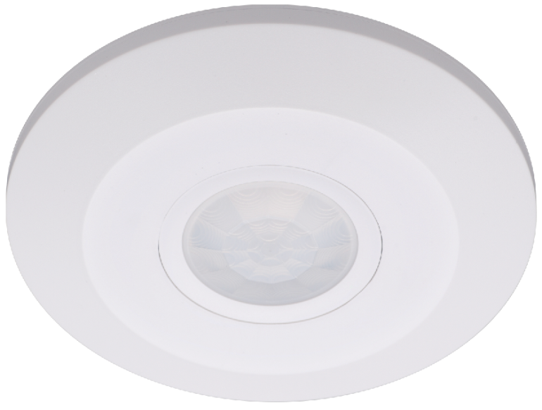C:\Program Files\Tencent\QQ\Users\1989254367\Image\Image1\LK%O2QTVDY{GCTWB_BF_AGT.jpg 1000W Detection Moving Speed: 0.6-1.5m/s

***INSTALLATION INSTRUCTIONS:***

**As the detector responds to changes in temperature, avoid the following situations:**

* Avoid pointing the detector towards objects with highly reflective surfaces, such as mirrors etc.
* Avoid mounting the detector near heat sources, such as heating vents, air conditioning units, light etc.
* 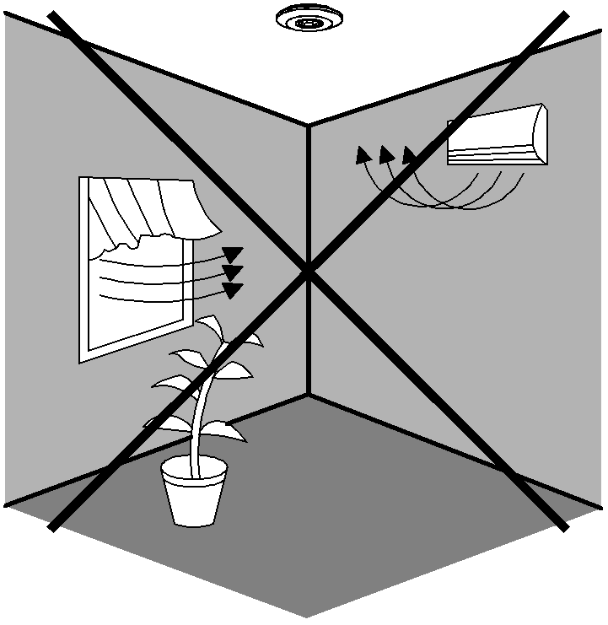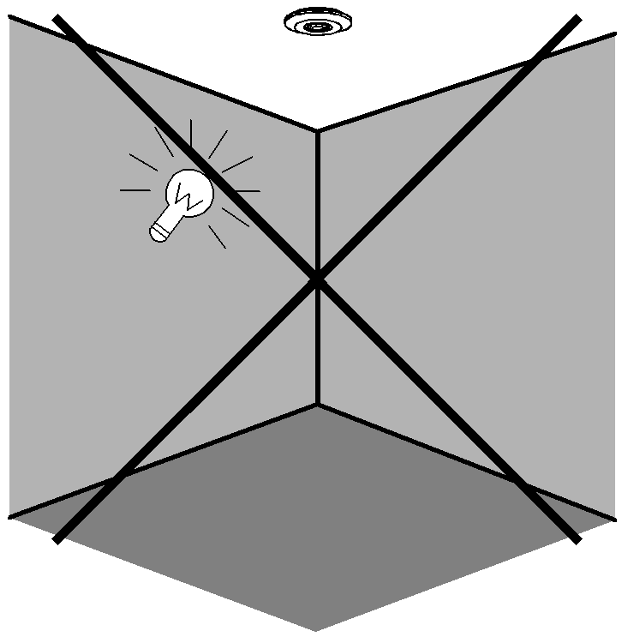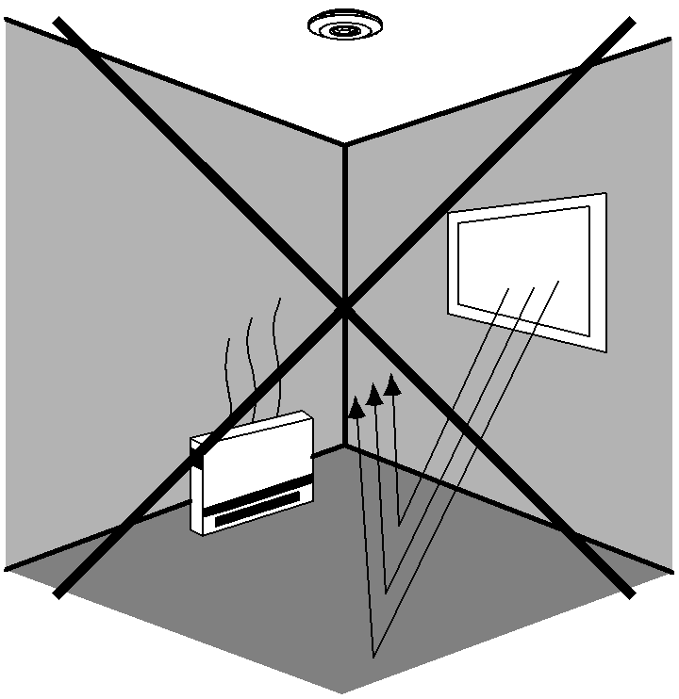Avoid pointing the detector towards objects that may move in the wind, such as curtains, tall plants etc.

***CONNECTION:***



 **Warning. Danger of death through electric shock!**

* Must be installed by professional electrician.
* Disconnect power source.
* Cover or shied any adjacent live components.
* Ensure device cannot be switched on.
* 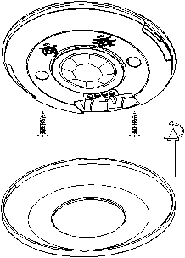Check power supply is disconnected.
* Please turn the upper cover anti-clockwise as per the diagram on the right.
* Connect the power and the load as per the wiring diagram.
* Fix the sensor to the installation surface.
* Place the cover back onto the sensor, then switch on the power and test it.

***WIRING DIAGRAM*** (See the diagram on the right)

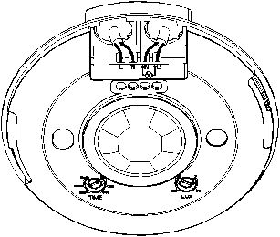

**Rear Cable Entry**

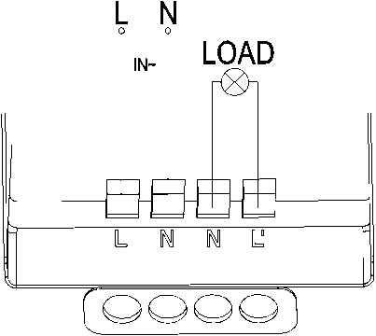

***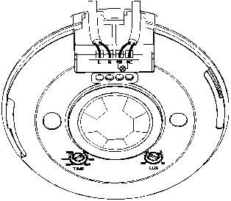***

**Side Cable Entry**

***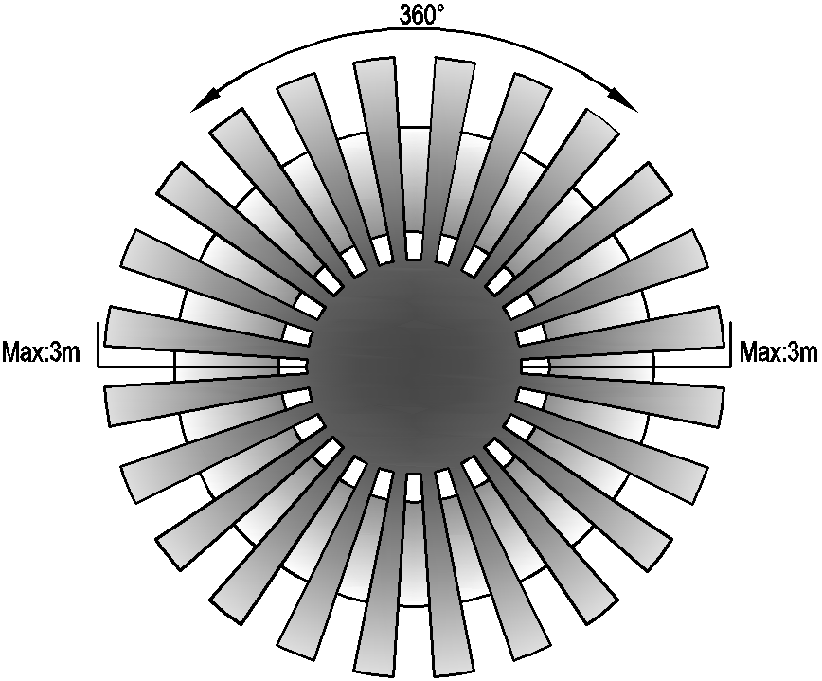***

***SENSOR INFORMATION:***

***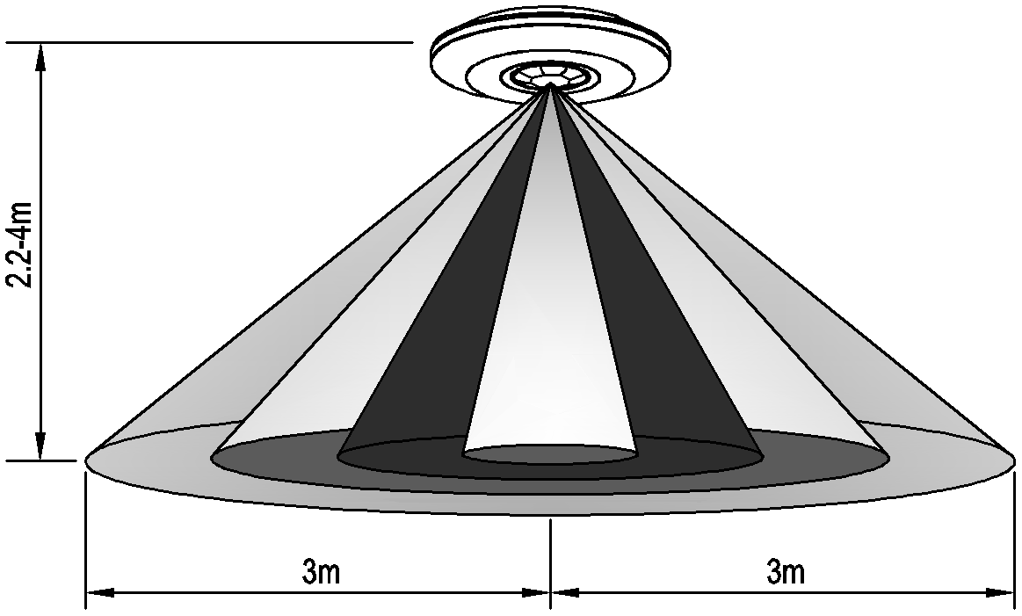***

***TEST:***

Detection Distance: Max.6m

Recommended installation Height: 2-4m

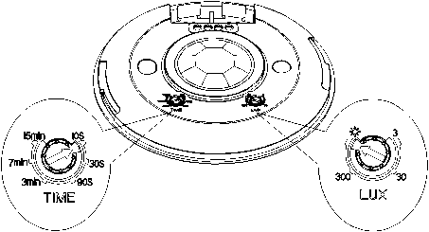

***TESTING THE SENSOR:***

* Adjust the hold time using the time control on the side of the sensor to 10 seconds.
* Switch on the power; the sensor and its connected lamp will have no signal to start with. After Warm-up 30sec, the sensor will work. If the sensor receives the induction signal, the lamp will turn on. When there is no induction signal, the load should stop working within 10sec±3sec and the lamp would turn off.
* Turn LUX control clockwise to the minimum (3). If the ambient light is more than 3LUX, the sensor will not be activated. If the ambient light is less than 3LUX (night time), the sensor will be activated.

***Note if testing during daylight, turn the lux control clockwise to the sun setting.***

**If the lamp is more than 60W, the distance between lamp and sensor should be 60cm at least.**

***TROUBLESHOOTING:***

* The load does not work:

a. Please check if the connection of power source and load is correct.

b. Please check if the load is ok.

c. Please check if the settings of on the sensor correspond to ambient light.

* The sensitivity is poor:

a. Please check if there is any obstruction in front of the detector that would cause the sensor not to receive a signal.

b. Please check if the ambient temperature is too high.

c. Please check if the induction signal source is in the detection field.

d. Please check if the installation height corresponds to the height recommended in the instruction leaflet.

* The sensor won’t switch off the load automatically:

a. Please check if there is continual signal in the detection field.

b. Please check if the time delay is set to the maximum position