Infrared Motion Sensor

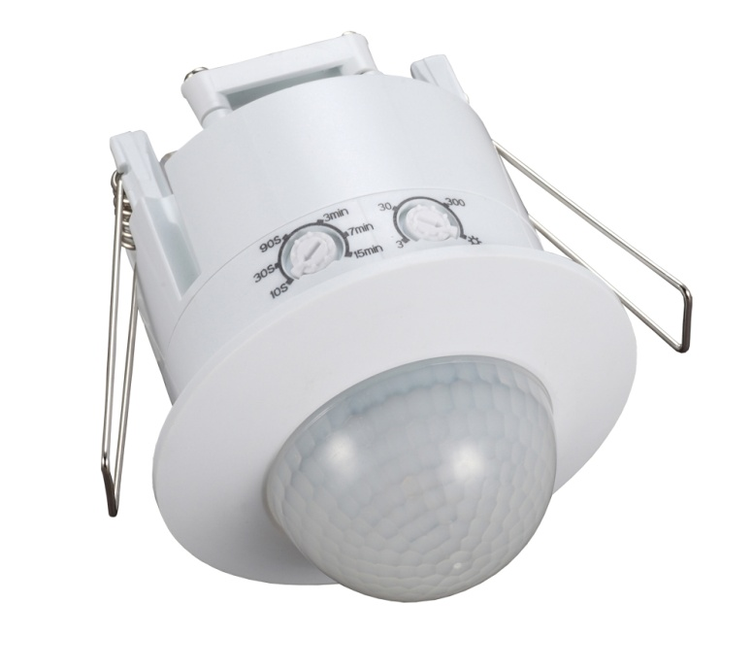

MS-12M-360

**Instruction Manual**

**MS-12M-360 Infrared motion sensor**

The sensor has great detection sensitivity via integrated circuitry. It utilizes the infrared energy from humans as the control-signal source.

***SPECIFICATION:***

Power Source: 220-240V/AC Detection Range: 360°

Power Frequency: 50/60Hz Detection Distance: 12m max (<24℃)

Ambient Light: <3-2000LUX (adjustable) Working Temperature: -20~+40℃

Time Delay: Min.10sec±3sec Working Humidity: <93%RH

Max.15min±2min Power Consumption: approx 0.5W

QQ图片20140704135149Rated Load: Max.1200W Installation Height: 2.2-4m

C:\Program Files\Tencent\QQ\Users\1989254367\Image\Image1\LK%O2QTVDY{GCTWB_BF_AGT.jpg 300W Detection Moving Speed: 0.6-1.5m/s

***INSTALLATION RECOMMENDATION:***

**As the detector responds to changes in temperature, avoid the following situations:**

* Avoid pointing the detector towards objects with highly reflective surfaces, such as mirrors etc.
* Avoid mounting the detector near heat sources, such as heating vents, air conditioning units and light etc.
* 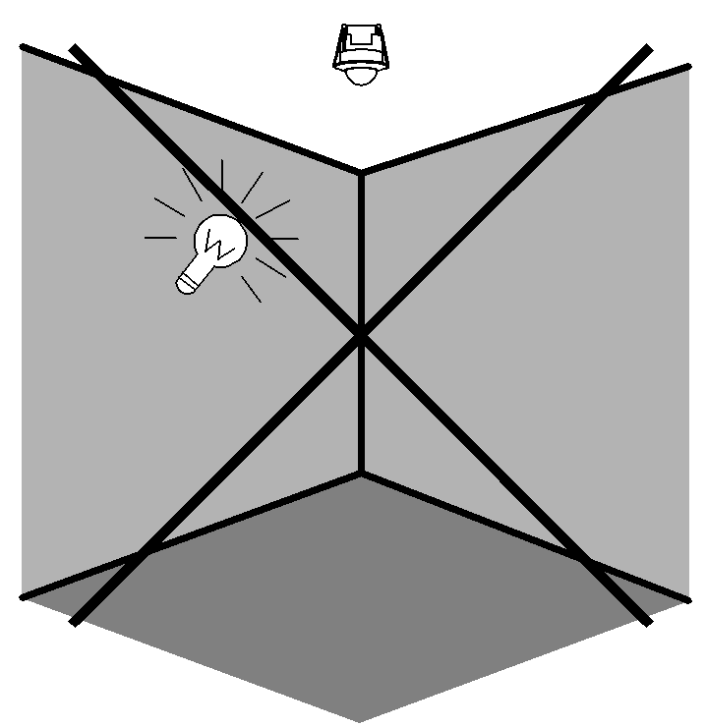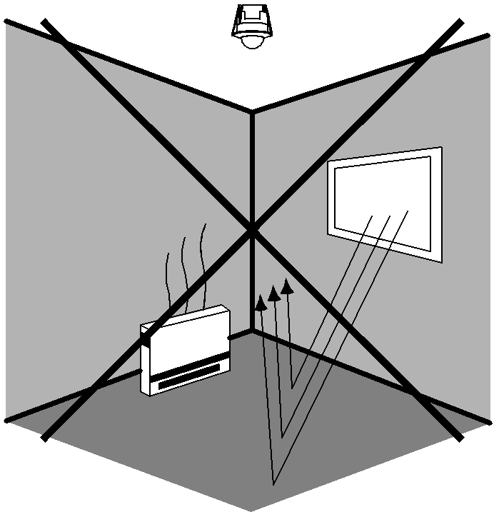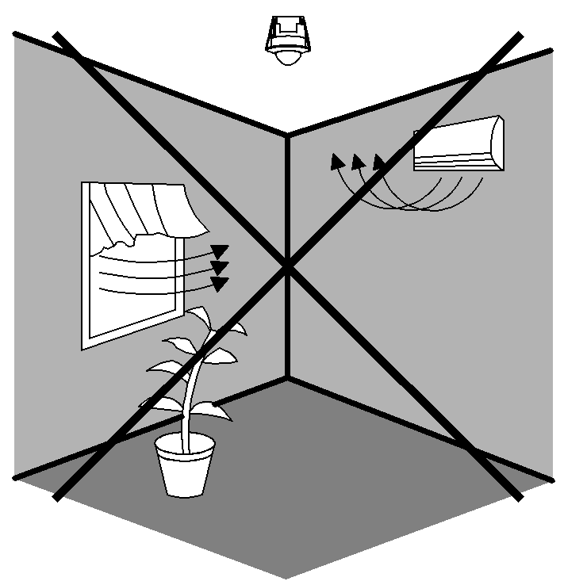Avoid pointing the detector towards objects that may move in the wind, such as curtains and tall plants etc.

***CONNECTION:***



 **Warning. Danger of death through electric shock!**

* Must be installed by professional electrician.
* Disconnect power source.
* Cover or shied any adjacent live components.
* Ensure device cannot be switched on.
* Check power supply is disconnected.
* Remove the transparent vinyl cover at the bottom of the sensor.
* Loosen the screws in the connection terminal, and then connect the power to the connection terminal of the sensor as shown on the wiring diagram.
* Put the transparent vinyl cover back into the original position.
* Fold the metal spring of the sensor upwards, until they are in a vertical position
* Then put the sensor into the hole or installation box which is in the ceiling. Release the spring, the sensor will then be set in this installation position.
* After installing, turn on the power and test it.

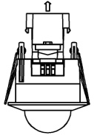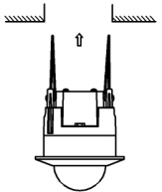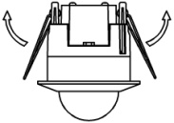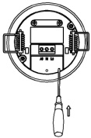

STEP 1 STEP 2 STEP 3

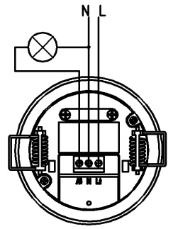

***WIRING DIAGRAM:***

(See the right figure)

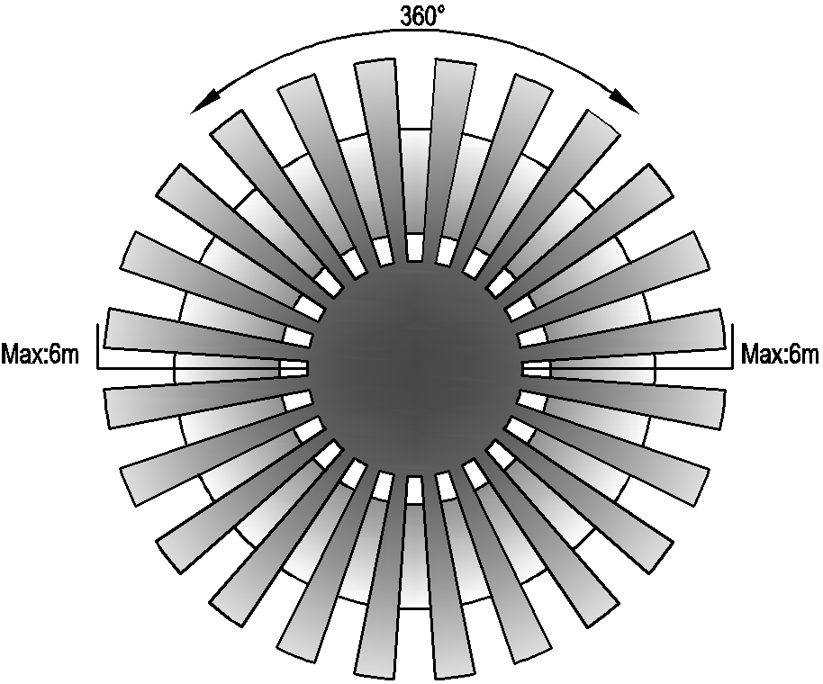***SENSOR INFORMATION:***

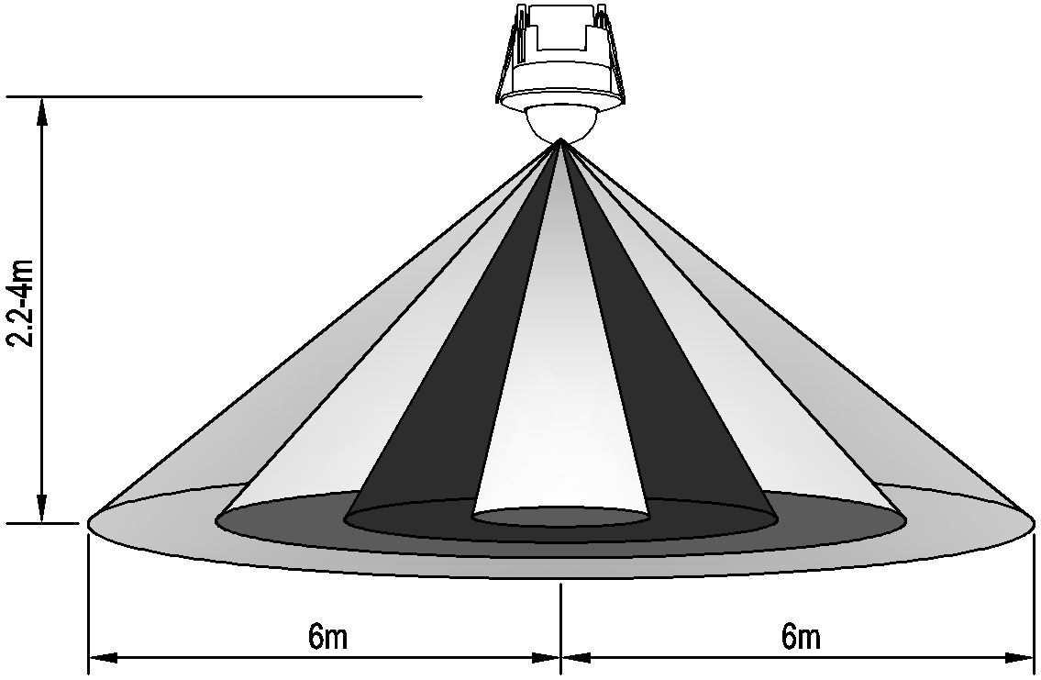

Height of installation: 2.2-4m

Detection Distance: Max.12m

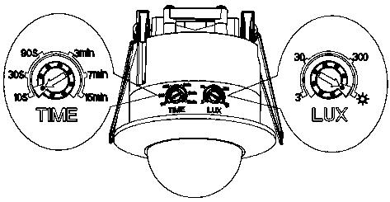

***TESTING THE SENSOR:***

* Adjust the hold time using the time control on the side of the sensor to 10 seconds.
* Switch on the power; the sensor and its connected lamp will have no signal to start with. After Warm-up 30sec, the sensor will work. If the sensor receives the induction signal, the lamp will turn on. When there is no induction signal, the load should stop working within 10sec±3sec and the lamp would turn off.
* Turn LUX control clockwise to the minimum (3). If the ambient light is more than 3LUX, the sensor will not be activated. If the ambient light is less than 3LUX (night time), the sensor will be activated.

***Note if testing during daylight, turn the lux control clockwise to the sun setting.***

***TROUBLESHOOTING:***

* The load does not work:

a. Please check if the connection of power source and load is correct.

b. Please check if the load is ok.

c. Please check if the settings of on the sensor correspond to ambient light.

* The sensitivity is poor:

a. Please check if there is any obstruction in front of the detector that would cause the sensor not to receive a signal.

b. Please check if the ambient temperature is too high.

c. Please check if the induction signal source is in the detection field.

d. Please check if the installation height corresponds to the height recommended in the instruction leaflet.

* The sensor won’t switch off the load automatically:

a. Please check if there is continual signal in the detection field.

b. Please check if the time delay is set to the maximum position